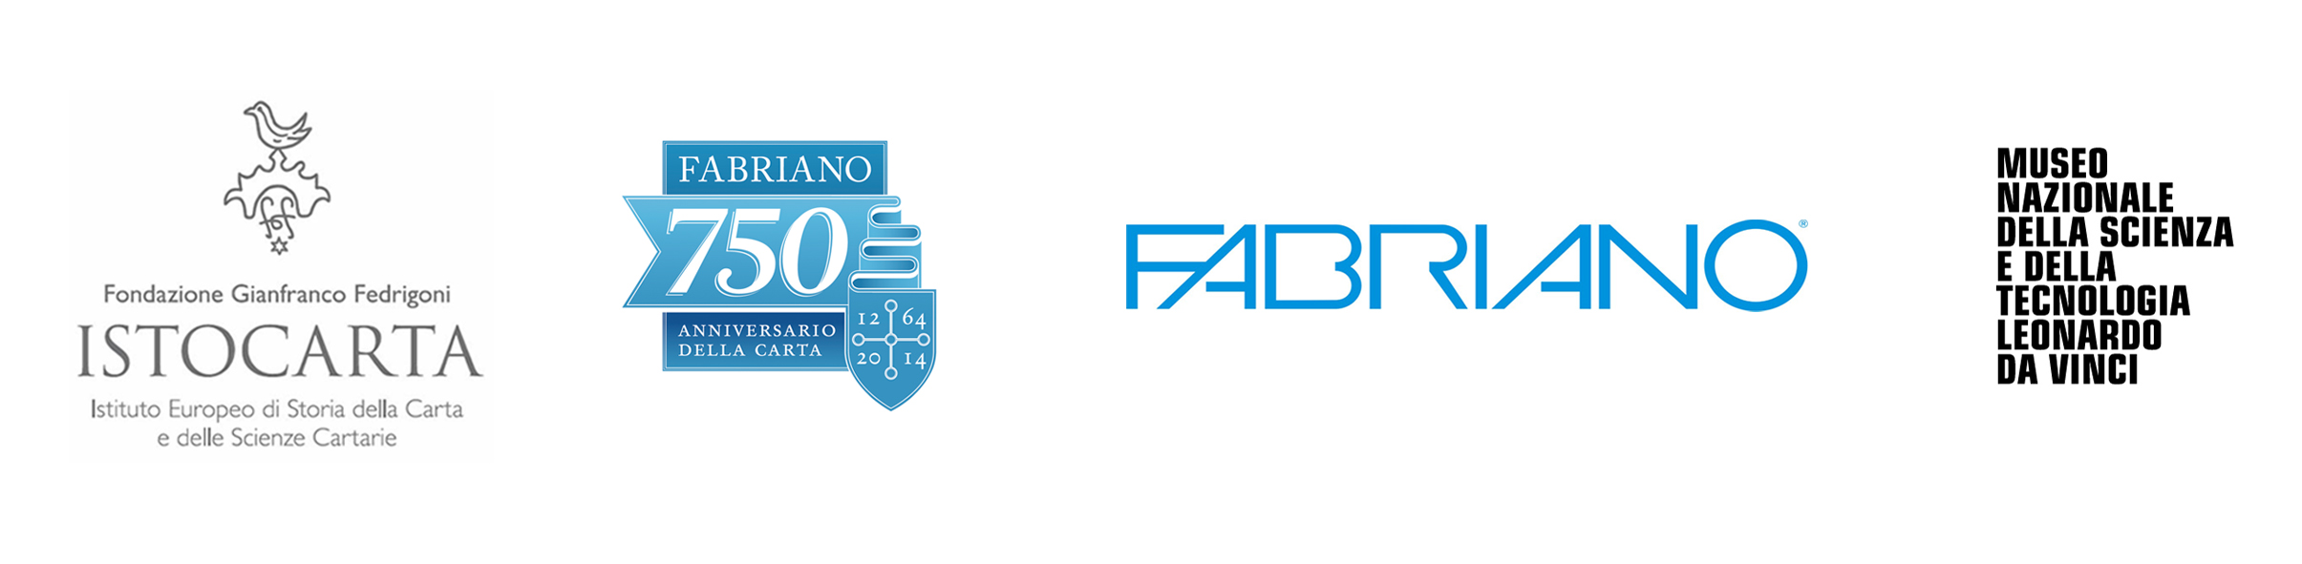

PRESS RELEASE
Fabriano, April 2nd, 2014

FABRIANO - ISTOCARTA - MUST
a collaboration of historical level - technical - scientific

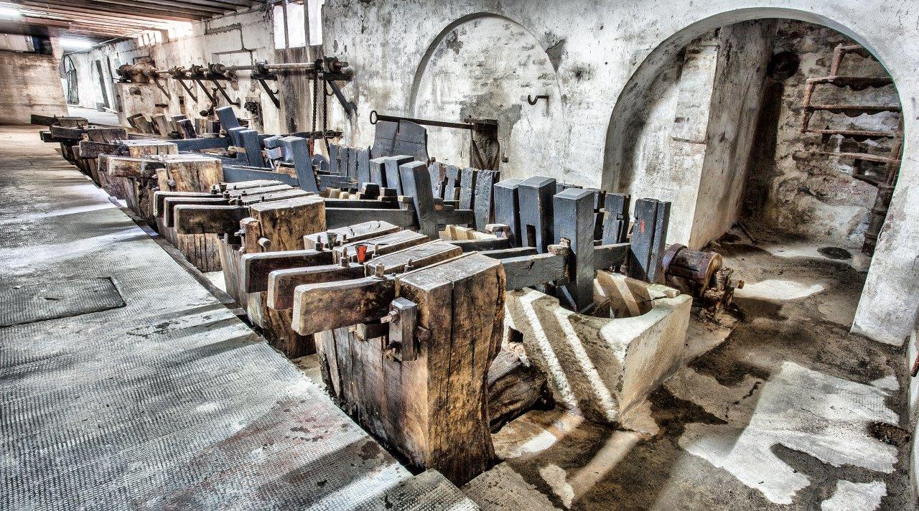
The water-driven multiple stamper of 18th century
conserved in the Miliani FABRIANO Paper Mills, from which the specimen of MUST originates

The inauguration of the new paper area of the National Museum of Science and Technology, Leonardo da Vinci (MUST), Milano (Italy) will be held on Friday, April 4th, 2014, in conjunction with the celebrations of the 750th anniversary of FABRIANO paper. It will be open to the public from Saturday, April 5th, 2014. The Paper Area is the project of MUST, who have agreed with FABRIANO paper mill to establish a partnership between the Museum and the Gianfranco Fedrigoni Foundation, European Institute of Paper and Paper Sciences (ISTOCARTA), Fabriano (AN), who has given full cooperation on the technical and scientific history. "MUST, founded in 1953, is now the largest technical and scientific museum in Italy and for some years has been undertaking a process of transformation that has had amongst its objectives: upgrading themes, re-interpreting collections and renewing exhibitions". From this came the need to renew the paper area of the museum around a historical object of great value: the water-driven multiple stamper from the 18th century and thanks to the partnership with FABRIANO, this has now been restored, renovated and re-equipped. The partnership has historical precedents, infact, the water-driven multiple stamper and many other machines and paper materials, presented at the museum, originated at Miliani Fabriano Paper Mills. They were donated or given into permanent storage at the then "Museum of Science and Technology", after their exposure at the Fiera di Milano, October, 3rd - 11th, 1959, at the Historical Exhibition of Paper and Print, in which, the Historical Archives of Miliani Fabriano Paper Mills, guarded by the Gianfranco Fedrigoni Foundation, European Institute of Paper and Paper Sciences (ISTOCARTA), Fabriano (AN) and the archive of MUST, have still retained the letters. ISTOCARTA, for its part, has provided valuable technical skills - historical - scientific, and has granted to Museum for the paper area to reproduce some historical photos dating from 1871 that are held in the photo library of the Historical Archives of Miliani Fabriano Paper Mills, representation of the main stages of pulp and paper production. The Gianfranco Fedrigoni Foundation, European Institute of Paper and Paper Sciences (ISTOCARTA), Fabriano (AN), along with the Historical Archives of Cartiere Miliani, Fabriano, will be incorporated inside the web-site dedicated to the scientific archives that the National Museum of Science and Technology Leonardo da Vinci (MUST) has recently launched.

For more information:

Dr Livia Faggioni
Coordinator
Fondazione Gianfranco Fedrigoni
ISTOCARTA
Istituto Europeo di Storia della Carta
e delle Scienze Cartarie

Viale Pietro Miliani, 31/33
60044 Fabriano (AN)
Phone. +39 0732 702502
Fax. +39 0732 702307
www.istocarta.it

